Supplementary Material
for the manuscript

Polyelectrolyte multilayers films as sacrificial, regenerable coatings for controlling surface fouling by emulsified oil

Peng Chen^{1,2}, Xunhao Wang², Volodymyr V. Tarabara^{2*}
¹ | College of Civil Engineering and Architecture, Zhejiang University of Water Resources and Electric Power, Hangzhou 310018, China
² | Department of Civil and Environmental Engineering, Michigan State University, East Lansing, MI 48824, USA

S1. Sample preparation for fluorescent microscopy
Nile Red is a fluorescent dye that exhibits strong fluorescence in high-concentration oil droplets. Previous studies have demonstrated that adding Nile Red solution to a diluted petroleum emulsion to achieve a final concentration of 38.2 μg/L (0.12 μM) (Gündoğdu et al. 2024) or staining hexadecane with 100 μg/L Nile Red (Grate et al. 2010) successfully enabled fluorescence observation.
In this study, the preparation process for the oil emulsion is detailed in the “Preparation of oil-in-water emulsion” section. Nile Red solution was added to the oil emulsion at the dye concentration of 100 μg/L. For storage, the flask with the emulsion was wrapped in aluminum foil to prevent light exposure.
QCM-D experiments with the emulsion were conducted following the procedure described in the “Quartz crystal microbalance with dissipation measurements” section, with sampling performed at different stages of the experiment.
To minimize errors caused by incomplete cleaning, Au crystals used for fluorescence microscopy testing were either brand new or had been used no more than twice. Prepared samples were immediately stored under light-protected conditions and promptly delivered for testing.
S2. Inputs to the XDLVO model: oil droplet size and zeta potential of oil droplets and PEM films.
Parameters |  | Value
 |  | pH=4 | pH=7 | pH=10
Zeta potential | [PSS/PDAD]₄, 10mM | 6.3 ± 0.6 mV | 6.6 ± 0.6 mV | 2.9 ± 0.6 mV
Zeta potential | [PSS/PDAD]₄, 100mM
Zeta potential | [PSS/PDAD]_{4.5}, 10mM | -10.6 ± 0.2 mV | -10.2 ± 0.2 mV | -10.9 ± 0.1 mV
Zeta potential | [PSS/PDAD]_{4.5}, 100mM | -72.2±2.8 mV
Zeta potential | [Chi/PMAA]₄, 10mM | -5.5 ± 0.6 mV | -5.9 ± 0.2 mV | -0.5 ± 0.4 mV
Zeta potential | [Chi/PMAA]₄, 100mM
Zeta potential | oil emulsion |  | -80.6 mV
Droplet size | oil emulsion |  | 200 nm
S3. Comparison of the Zeta potential (pH=7) of PEMs in pure water and in SDS solution
 | [PSS/PDAD]₄, | [PSS/PDAD]_{4.5}
Pure water | 6.7 ± 2 mV ª | -5.7 ± 2 mV ª
SDS solution | 6.6 ± 0.6 mV | -10.2 ± 0.2 mV
- Data reported in our previous studies (Dang and Tarabara 2019).
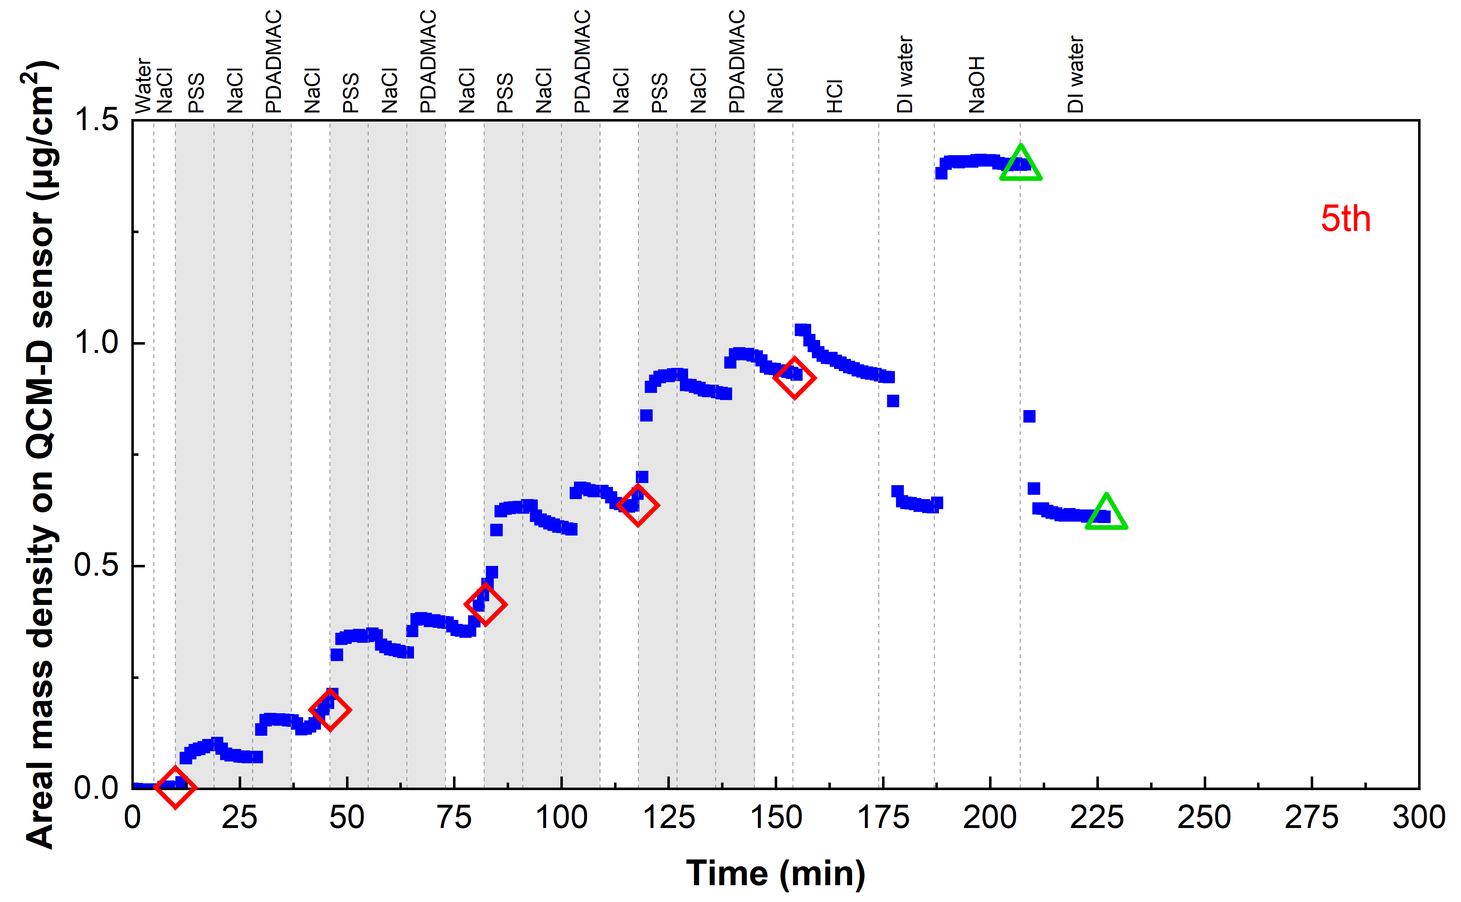
Figure S1. Example QCM-D data set: assembly and disassembly of [PSS/PDAD]₄ layers on Au-coated QCM-D sensor
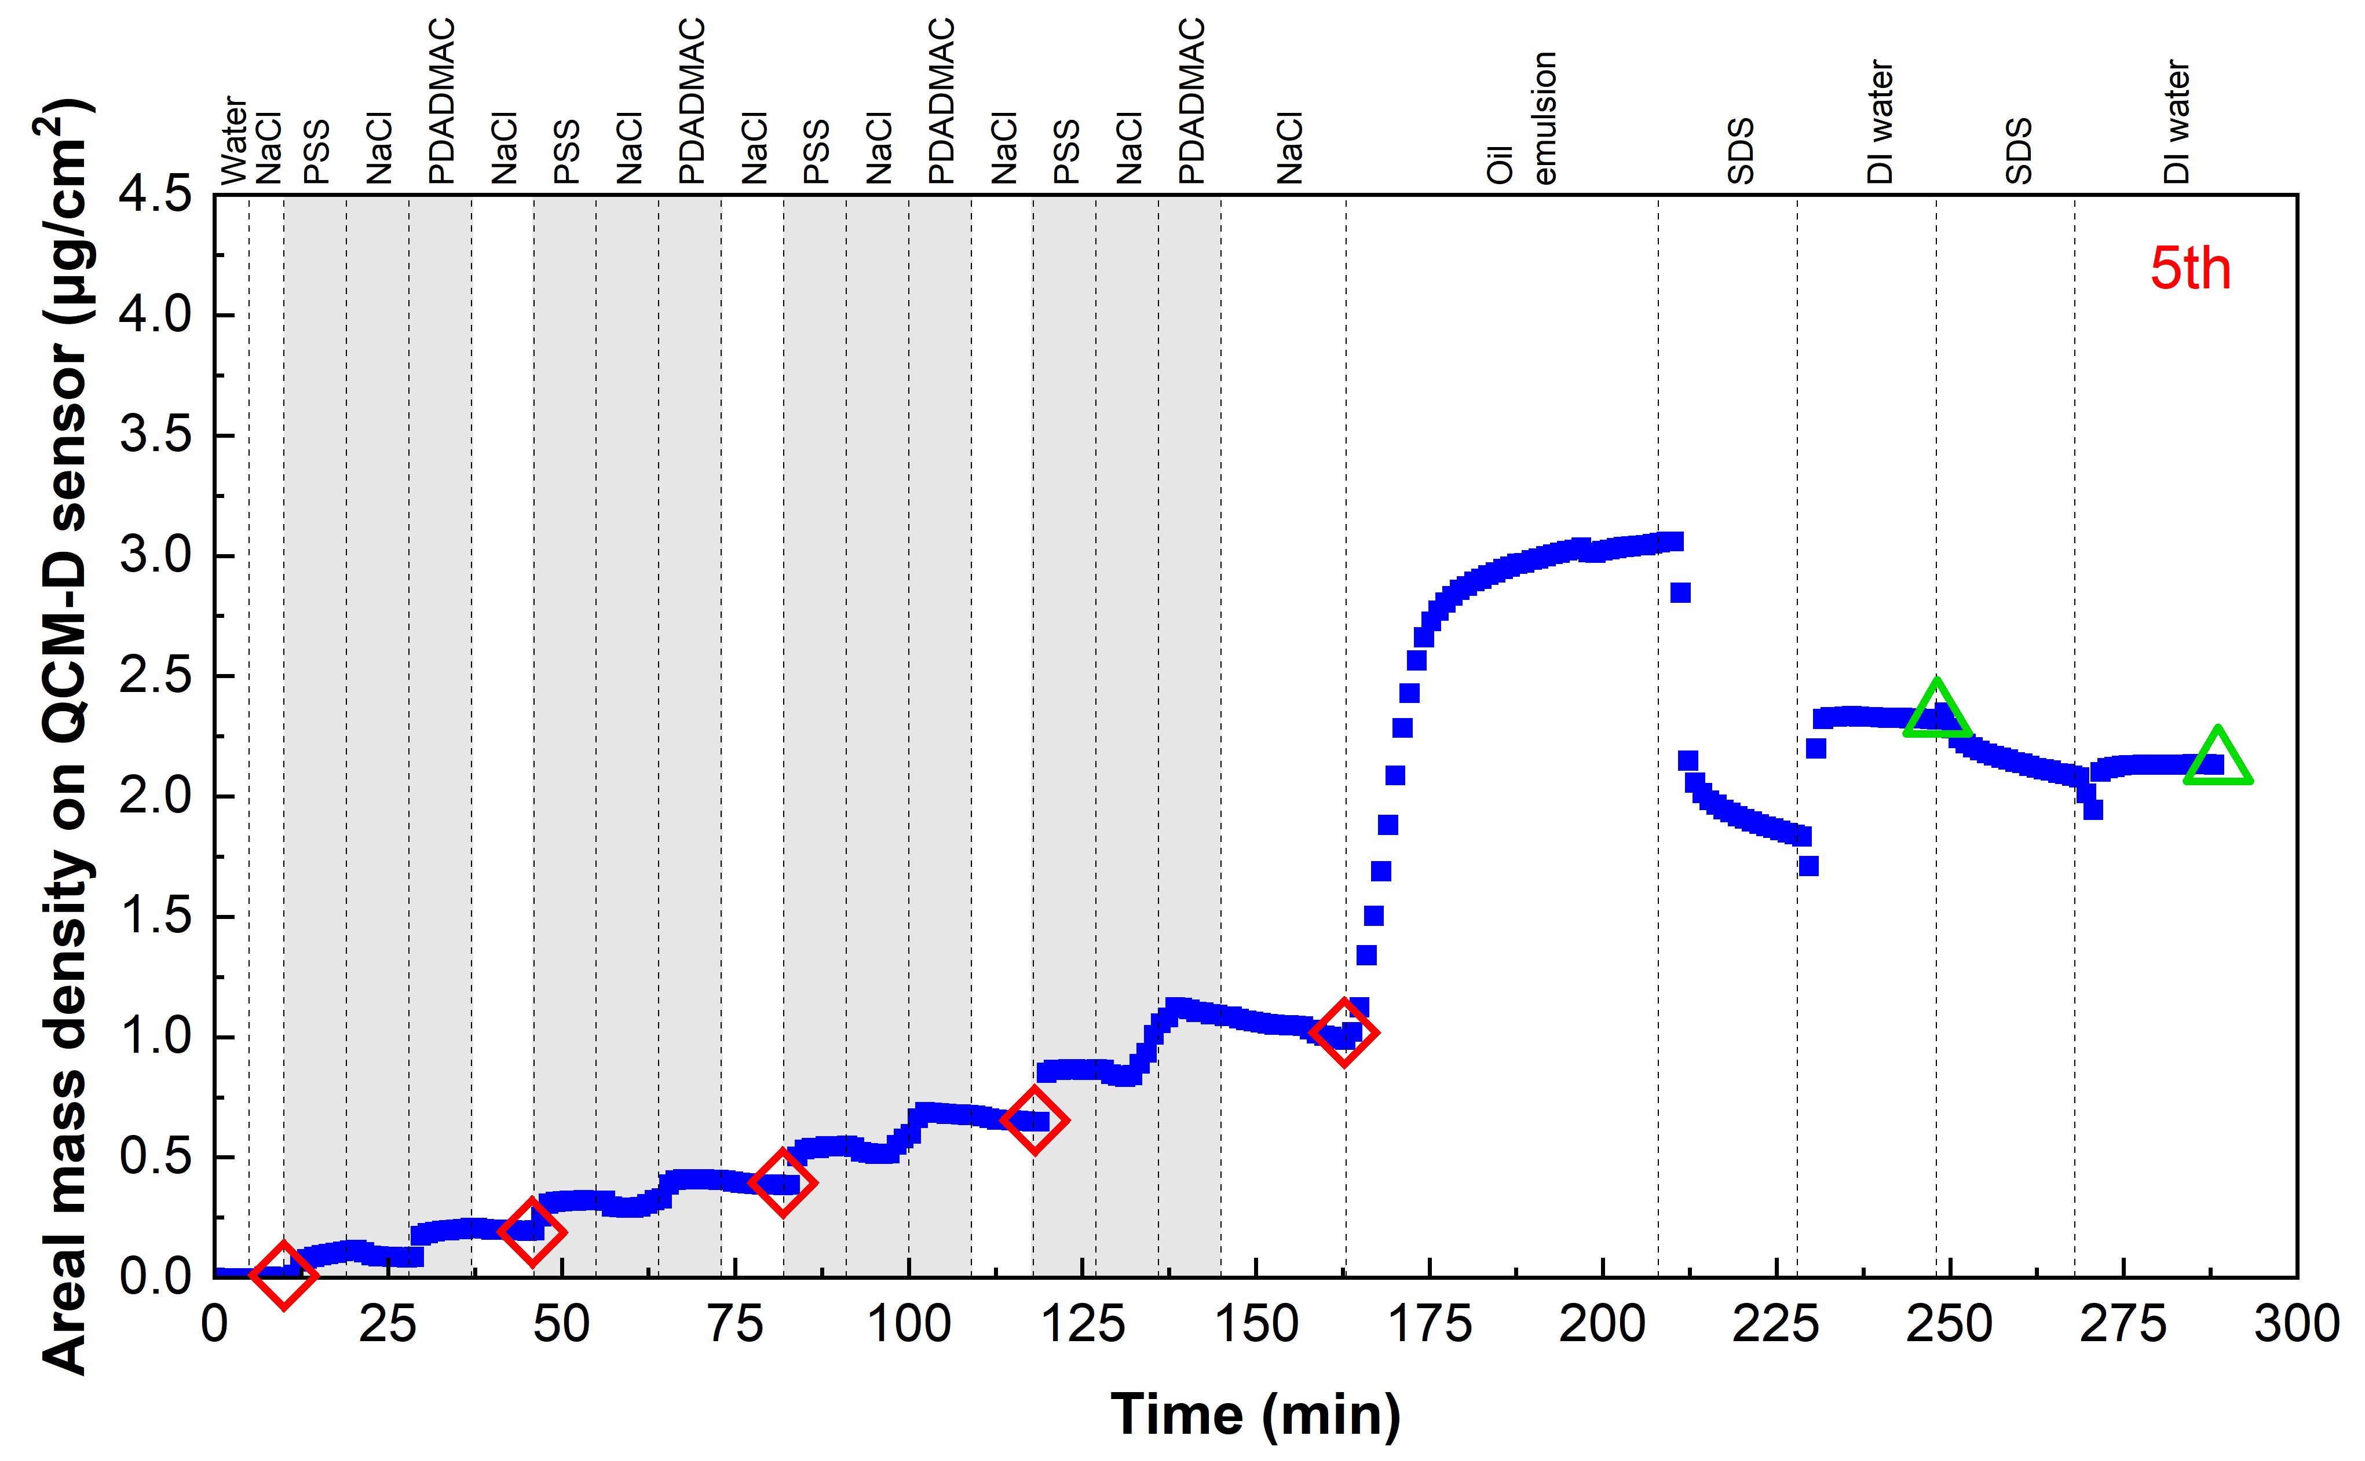
Figure S2. Example QCM-D data set: assembly and disassembly of [PSS/PDAD]₄-oil layers on Au-coated QCM-D sensor washing by SDS solution. The data are based on the 5th harmonic of the QCM-D signal.
(a) Oil-[PSS/PDAD]₄ in 100 mM | (b) Oil-[PSS/PDAD]_{4.5} in 100 mM
Figure S3. XDLVO and DLVO energies of interfacial interaction between oil droplets and two PEM coatings - (a) [PSS/PDAD]₄ and (b) [PSS/PDAD]_{4.5} - in aqueous media of two different ionic strengths - 100 mM.
S4. Calculation of shear stress
$$τ=6μ\frac{V_{s}}{L}\left(1-\frac{x}{L}\right)$$
where
$τ$ is shear stress (Pa),
$V_{s}=0.017$ cm/s is average fluid velocity in the QCM-D channel,
$L=0.00149$(m) is the thickness of the O-ring or flow channel,
$x= 0.00001$(m) is the distance from the sensor surface, and
$μ=1×{10}^{-3}$ (Pa.s) is the dynamic viscosity of water.
Substituting the given values, one obtains $τ=0.68 mPa$.
References
Dang, H. T. T., and V. V. Tarabara. 2019. “Virus deposition onto polyelectrolyte-coated surfaces: A study with bacteriophage MS2.” J. Colloid Interface Sci. 540 (Mar): 155–166. https://doi.org/10.1016/j.jcis.2018.12.107.
Grate, J. W., C. Zhang, T. W. Wietsma, M. G. Warner, N. C. Anheier Jr., B. E. Bernacki, G. Orr, and M. Oostrom. 2010. “A note on the visualization of wetting film structures and a nonwetting immiscible fluid in a pore network micromodel using a solvatochromic dye.” Water Resour. Res. 46 (11): W11602. https://doi.org/10.1029/2010WR009419.
Gündoğdu, G., E. Yılmaz Topuzlu, F. Mutlu, U. E. Ertekin, and H. I. Okur. 2024. “Oil-in-water emulsions probed using fluorescence multivariate-curve-resolution spectroscopy.” Langmuir 40 (25): 13116–13121. https://doi.org/10.1021/acs.langmuir.4c01018.

